**Q1. Write a program to print the statement by using the c++?**

**Solution 1:**

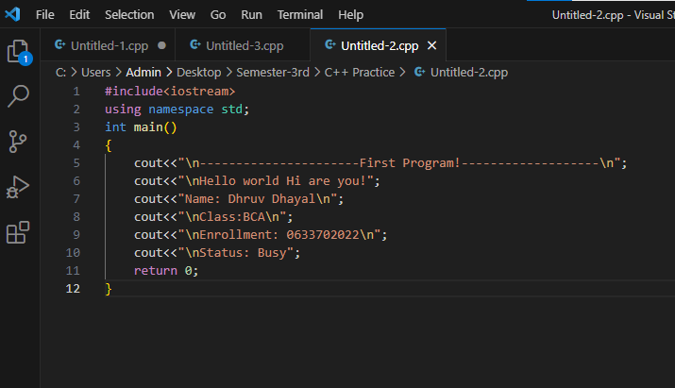

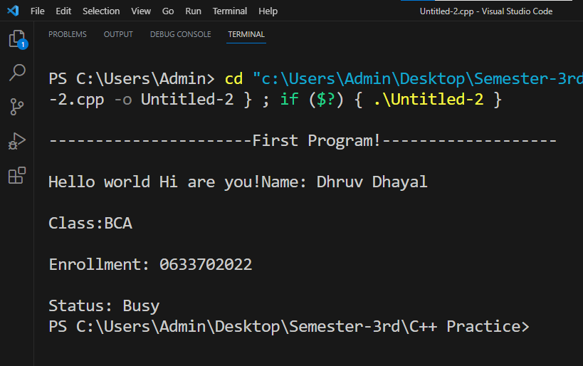

**Q2. Write a Program to print all Arithmetic Function in Integer/ Float Values?**

**Solution 2:**